Project Development Phase
Model Performance Test

Date | 06 July 2026
Team ID
Project Name | Personalised Networking Assistant
Maximum Marks

Model Performance Testing:
Project team shall fill the following information in model performance testing template.
S.No. | Parameter | Values | Screenshot
 | Model Summary | Pre-trained KeyBERT with DistilBERT was used for keyword extraction and conversation topic generation. No custom model training was performed. | 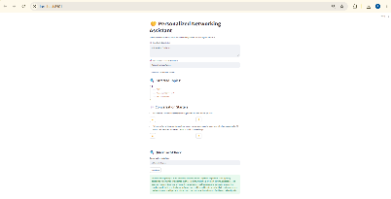
 | Accuracy | Training Accuracy: Not Applicable (Pre-trained Model)  Validation Accuracy: Not Applicable (No custom training performed) | • Training Accuracy: N/A (Pre-trained Model)  • Validation Accuracy: N/A (Pre-trained Model)
3. | Fine Tunning Result( if Done) | Not Applicable (Fine-tuning was not performed.) | N/A

